STA 2023 Practice Questions Chapter 1 to Sec 6.3

These practice questions are not a substitute for doing the homework or studying the notes.

You need to know the z-score formula.

Formulas given on exam.

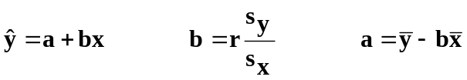 res= obs y – pred y
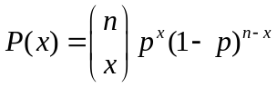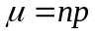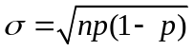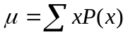

P(A and B) = P(A) P(B) P( A | B) = P( A and B) / P(B)

Here is a stemplot of the scores of Bob the Bowler’s last 18 bowling games, made by Minitab. Use this graph for questions 1-3

Stem-and-leaf of Bowling N = 18
Leaf Unit = 1.0

1 9 4
1 10
1 11
2 12 8
4 13 12
7 14 346
(6) 15 147799
5 16 01445

1. What is the best description for the shape of this graph?
a) Bell/Mound-shaped
b) Skewed to the left
c) Skewed to the right
d) Uniform

2. Where is the center of this graph?
a) Around 105
b) Around 135
c) Around 155
d) Around 165

3. Does this graph have any outliers?
a) Yes, 94 is an outlier
b) Yes, 165 is an outlier
c) No, the numbers are too close together
d) No, N is too small to have outliers

One semester, the TA for a math class decided to time how long it took her students to finish their Final Exam. Below is a histogram of the results. Use this graph for questions 4-6
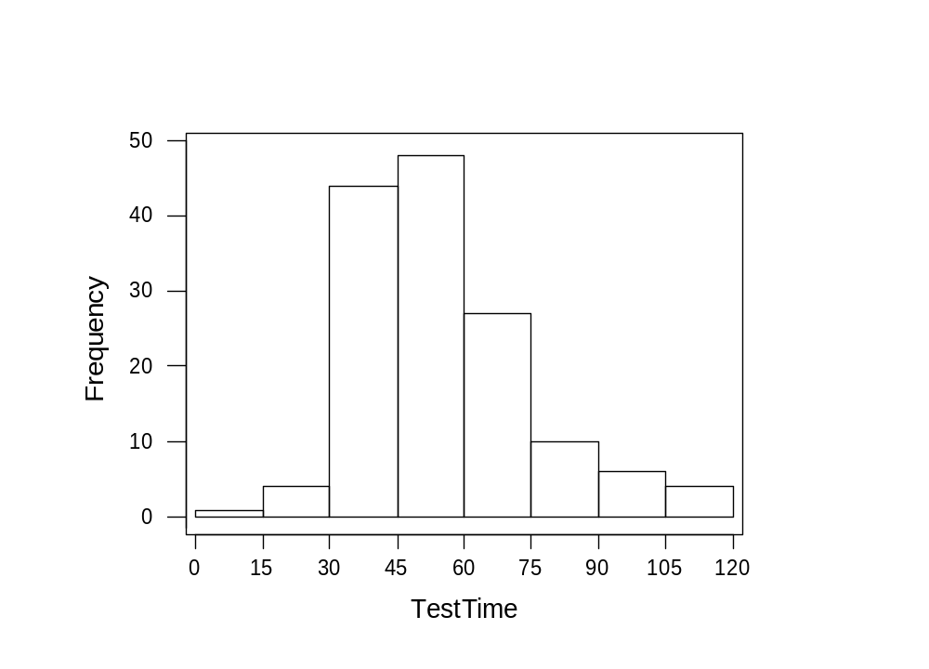
4. About how many students took longer than 90 minutes to finish their test?
a) About 5
b) About 10
c) About 20
d) About 105

5. Where is the center of this graph?
a) Between 15 and 30 minutes
b) Between 45 and 60 minutes
c) Between 75 and 90 minutes
d) Between 105 and 120 minutes

6. How will the mean and median of these test times relate, based on the graph?
a) The mean will be slightly larger than the median
b) The mean will be slightly smaller than the median
c) The mean and median will be exactly equal.
d) It is impossible to tell from this graph

The Gators’ Woman Basketball team has played 19 games as of 1/25/02. Here is a stemplot, made by Minitab, of the number of points the Lady Gators have scored in each game so far. Use this graph for questions 7-10

Stem-and-leaf of Scores N = 19
Leaf Unit = 1.0

1 4 9
3 5 19
7 6 1248
(5) 7 03588
7 8 01348
2 9 03

7. What is the median of this data?
a) 10
b) 73
c) 75
d) 78

8. What is the IQR (Interquartile Range) of this data?
a) 10
b) 13
c) 21
d) 62

9. What is the standard deviation of this data?
a) 12.78
b) 44
c) 93
d) 163.33

10. If z is a standard normal random variable, what is the variance of z?
a) 0
b) 1
c) 4
d) It depends on what kind of standard normal variable you have

A particular type of 4th grade Achievement Test provides overall scores that are normally distributed with a mean of 50 and a standard deviation of 10. Use this information for questions 11-14

11. What is the probability that a randomly selected student earns a score of at least 42?
a) .7881
b) .2881
c) .2119
d) .1921

12. What is the probability that a randomly selected student earns a score between 33 and
48?
a) .3761
b) .4207
c) .4653
d) .0446

13. One state wants to allow all students with scores in the top 3% into a special advanced program. What will be the minimum score required to be admitted into this program?
a) 1.88
b) 31.2
c) -1.88
d) 68.8

14. Suppose that after the first exam you compute the z-score that corresponds to your exam score on Exam 1. Your z-score was -1.34. Which of the following can you say about your score on Exam 1?
a) You scored above the mean on Exam 1.
b) You scored exactly the mean on Exam 1.
c) You scored below the mean on Exam 1.
d) This can not be determined from the above information.

Questions 15-17 use the following information.
Suppose you are a marine biologist studying a particular species of whales. The average length of this whale species is 60 feet and the standard deviation is 12 feet. The average length of whales in Normally distributed.

15. You find one member of this particular species of whales and measure it to find its length is 48 feet. What is the z-score corresponding to the length of this whale?
a) 2
b) -2
c) –1.0
d) 1.0

16. What is the probability you find a whale smaller than the one referred to in the previous question?
a) .8413
b) .1587
c) .4801
d) -.4801

17. You find old research on this species of whales that only reports the z-scores of lengths and not the actual lengths of whales. One particular whale stands out to you because it has a z-score of 5.2. What does the z-score tell you?
a) This whales is much larger than the mean.
b) This whale is much smaller than the mean
c) The whale is an average length
d) Not enough information is given.

18. Which of the following is a true statement? (Assume that the first quartile and minimum for this data set are not equal.)
a) the IQR is always bigger than the range for a given data set.
b) the IQR is always smaller than the range.
c) the IQR is equal to the range.
d) this cannot be determined from the given information.

19. Which of the following is not true about normal curves?
a) They all have mean 0.
b) They are all symmetric.
c) The area underneath the curve is equal to 1.
d) They are all bell shaped.

20. What is the biggest advantage of the standard deviation over the variance?
a) The standard deviation is always smaller than the variance.
b) The standard deviation is calculated with the median instead of the mean.
c) The standard deviation is better for describing skewed distributions.
d) The standard deviation is in the same units as the original data.
Questions 21-23 use the following information
Suppose you operate a diamond mine in South Africa. The daily production of diamonds is approximately normally distributed with a mean of 7,500 tons of diamonds per day with a standard deviation of 1,500 tons of diamonds per day.

21. What is the probability that the mine produces more than 9,200 tons of diamonds in a day?
a) .1292
b) .8708
c) .5478
d) .4522

22. What is the probability that the mine produces between 5,400 and 8,200 tons of diamonds in a day?
a) .6808
b) .0808
c) .60
d) .7616

23. What is the probability that the mine produces between 4,500 and 9,000 tons of diamonds in a day?
a) 68%
b) 95%
c) 79%
d) 81.5%

For questions 24 An orthopedic surgeon treats many women for back pain. She suspects that one common carried item, the woman’s purse, might contribute to this, especially if the purse was heavy. She sampled the purses of 44 women with back pain who were clients at the clinic and got these statistics:

Variable N Mean Median TrMean StDev SE Mean
pursepai 48 4485 4000 4143 2958 427

Variable Minimum Maximum Q1 Q3
pursepai 1500 16000 2900 4875

24. What can we say about the shape of this distribution by looking at the output?
- symmetric
- skewed right
- skewed left
- It cannot be determined from the information given.

For questions 25-26 A random sample of 40 middle-class parents is asked how much money they spent on the most recent birthday gift (not including parties or celebrations) for one of their children. Their answers (in dollars) were as follows:
Stem-and-leaf of giftspri N = 40
Leaf Unit = 1.0

4 1 5888
11 2 1112677
(10) 3 0133335568
19 4 12255
14 5 147
11 6 99
9 7 225
6 8 47
4 9 0
3 10
3 11 7
2 12 0
1 13 5

25. “About how much money do most middle-class American parents spend on birthday gifts for their children?”
To answer this question, we would want to find this sample’s:
- mean
- median
- variance
- standard deviation

26. Which statement about the median is true?
- The median can be found in position # 21 on the stemplot.
- The median is smaller than the mean.
- The median is $36.
- The median is approximately $50.

For questions 27-30 A popular news magazine wants to write an article on how much Americans know about geography. They devise a test that lists 100 cities in the US, all of them mentioned in the news magazine in the last year. Each respondent must guess the state in which the city can be found. Some examples were: (Los Angeles, Tuscon, Biloxi.) Each correct answer earns one point, for a maximum of 100. The random sample of 5000 people had a distribution of scores that was normally distributed with mean 62 and standard deviation 12.

27. The central ninety-five percent of the people in this sample can identify how many states correctly?
- 38-86
- 50-86
- 50-74
- 26-98

28. What percentage of those sampled scored between 50 and 74 points?
- 68%
- 95%
- ~ 90%
- ~ 82%

29. What kinds of scores will the top 5% of people achieve?
- 78 or better
- 81.74 or better
- 90.25 or better
- 98 or better

30. Correctly matching 45 of 100 cities to states is considered a poor performance. What percentage of respondents in this sample scored this low?
- 9.93%
- 7.78%
- 6.55%
d) 5%

Questions 31-34 use the following scenario:
Suppose that you have decided to buy an ice cream truck to go into the ice cream business this summer instead of getting a summer job. You collected data every day last summer while working for an ice cream company about the temperature (in °F) and sales (in dollars) for that day as a way to research for your new business. You decided to fit a regression line and get the following based off of your data

Sales = -762 + 18.53*Temperature R² = 47.1%

31. Which of the following is the proper interpretation of the slope?
a) For every one dollar increase in Sales, Temperature will increase on average by 18.53 degrees.
b) For every one degree increase in Temperature, Sales will increase on average by 18.53 dollars.
c) When the Temperature is 0 degrees, Sales will be 18.53 dollars, on average.
d) When the Sales are 0 dollars, Temperature will be 18.53 degrees, on average.

32. What is the correlation between these two variables?
- 0.6862944
- -0.6862944
- 0.221841
d) -0.221841

33. The range of the variable Temperature that you observed was 72°F - 100°F. You hear a weather report saying a massive heat wave is coming your way and the high in your town will be 120°F tomorrow. You decide that you would like a prediction of your sales tomorrow since you presume you will make so much money. You use your regression equation to predict your sales for tomorrow and get a predicted value of $1461. What error have you made?
- restricted range problem
- misinterpretation of the slope and intercept
- misuse of cause and effect
d) extrapolation
34. Let’s say that on July 4 the temperature outside was 90°F and you sell 1100 dollars worth of ice cream. Which of the following is the residual for that day?
- $905.70
- -$194.30
- $194.30
d) -$905.70

35. Which of the following points will always lie in a Least Squares Regression line?
- (x , x)
b) 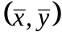
c) (s_{x} , s_{y})
d) (0, 0)

36. Suppose you are designing an experiment with one factor and that factor has 3 levels. You have 12 people in your experiment and assign each one a treatment by pulling a piece of paper out of a hat with either an "A", "B", or "C" on it. Which part of the experimental design process have you just completed?
- Control
- Randomization
- Replication
- Matched pairs

37. You manufacture consumer electronics and want to get feedback from your customers about their perception of your company. To do this you include a small survey in every one of your products sold and ask that your customers send it back to you for their feedback. Which of the following best describes what kind of sample this is?
- Simple Random Sample
- Probability Sample
- Voluntary Response Sample
d) Stratified Random Sample

38. You are a biologist and got to the jungles of Central America to gather data about the species of mammals native to that region in their natural environment. What kind of study are you conducting?
- Experiment
b) Survey
c) Completely Randomized Design
d) Observational Study

39. Suppose you are measuring the effect of two fertilizers, X and Y. You decide to design an experiment that involves two plant species, A and B. In your design you decide to make it easy on the lab technician and always give plant species A fertilizer X and plant species B fertilizer Y. Which error have you made in your design?
- Confounding the Variables Effects
b) Undercoverage
c) Restricted Rage Problem
d) Lack of Realism

40. You decide to test out a new teaching method by splitting up 10 pairs of identical twins into two groups, so that one of each pair of twin is in each group. You then apply your new teaching method to the first group and the standard teaching method to the second group. After a six week period you give both groups a test and compare the results on the test for each set of twins. Which of the following best describes the type of experiment that you have done?
- Matched Pairs experiment
b) Observational study
c) Double Blind study
d) Simple random Sample

41. Consider the following scatterplot of results of the Gator Men’s Basketball game scores as of February 19, 2002 (with Opponent’s scores as x and Florida’s scores as y).
How can you best describe the relationship between Florida’s scores and their opponent’s scores?
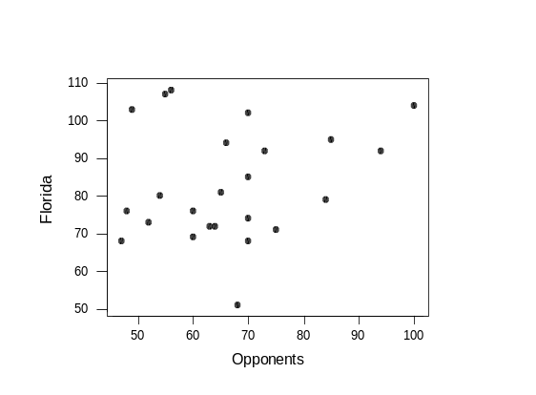
a) There is no real relationship between x
and y in this scatterplot.

a) There is no real relationship between x and y in this scatterplot.
b) There is a strong, positive linear relationship between x and y.
c) There is a strong, negative linear relationship between x and y.
d) There is a strong, curved relationship between x and y.

For Questions 42-44, consider the following data set.
A recent study was done to try to determine if a student’s grade in a class can be used to help predict the evaluation of the teacher as given by the student. Ten students were randomly selected from a class, and each student’s grade and overall teacher evaluation (both out of 100 points) were recorded. Minitab reports that the correlation is 0.755. Here is that data:

Student 1 2 3 4 5 6 7 8 9 10 mean stdev
Grade 94 85 57 78 81 91 62 55 70 74 74.7 13.66
Evaluation 91 88 85 77 79 95 66 60 71 72 78.4 11.35

42. How would we interpret the correlation of this data?
a) 75.5% of the variability in grades is explained by evaluations.
b) 75.5% of the variability in evaluations is explained by grades.
c) There is a fairly strong, positive linear relationship between evaluations and grades.
d) There is a fairly strong, negative linear relationship between evaluations and grades.

43. What is the intercept of the least squares regression line for this data?
a) –0.63
b) 16.33
c) 31.5
d) 57.0

44. If the data point (57, 85) were removed from the study, what would happen to the least squares regression line?

a) There would be little change since this point falls in line with the others.
b) Since this point is an outlier but not influential, it would only strengthen the
correlation of the line.
c) Since this point is an outlier but not influential, it would only weaken the
correlation of the line
d) Since the point is an influential outlier, it would change the direction of the
slope of the line.

For Questions 45-48, consider the following situation:

Alcohol abuse researchers wanted to determine if the number of alcoholic drinks per week drunk by a successful college student had any impact on his/her studies (and in particular, on his/her GPA). Sixty graduating seniors were selected at random and asked what their GPA was and how many drinks they had, per week, throughout their college career. Here is Minitab’s analysis of the least squares regression line for this data:

The regression equation is
gpa = 3.45140 - 0.0592606 drinks

S = 0.386810 R-Sq = 31.8 % R-Sq(adj) = 30.6 %

45. How would we interpret the slope of this equation?
- For each one additional drink per week, the student’s GPA should increase by .059 points, on average.
- For each one additional drink per week, the student’s GPA should decrease by .059 points, on average.
- For each 3.45 additional drinks per week, the student’s GPA should decrease by .059 points, on average
- It is inappropriate to interpret the slope for this equation, since R² is so small.

46. How would we interpret the intercept of this equation?
- If a student did not drink, we expect his/her GPA to be 3.45.
- If a student did not drink, we expect his/her GPA to be .059.
- If a student’s GPA was 0.0, we expect that he/she consumed 3.45 drinks per week.
- It is inappropriate to interpret the intercept for this equation, since graduating seniors cannot have a GPA of 0.0.

47. How would we interpret R² for this equation?
- 31.8% of the variability in GPA is explained by the number of drinks per week.
- 31.8% of the variability in the number of drinks per week is explained by GPA.
- 31.8% of the variability in GPA cannot be explained.
- It is inappropriate to interpret R² for this equation, since it is so small.

48. What is the correlation between GPA and number of drinks per week?
- 0.318
- 0.564
- –0.564
- It is impossible to determine from the information given.

For Questions 49-50 A study was conducted several years ago in the military to determine if shaving men’s heads was effective in decreasing insubordination among new recruits. Two hundred new recruits were randomly selected, and 100 of them had their head shaved, while the other 100 were free to choose whichever hairstyle they wanted. Among the 100 shaved men, six had disciplinary problems; amongst the 100 unshaved men, there were 22 with a disciplinary problem.

49. What percentage of the soldiers had disciplinary problems in this study?
- 6/100 b) 22/100 c) 28/200 d) 100/200

50. This study is an example of a(n):
- experiment b) observational study
c) survey d) None of the above

For questions 51-53 A car manufacturing plant is striving to decrease the number of injuries occurring on the assembly line. They hope that training workers on safety measures and proper operation of the machines will reduce the number of work hours lost to injury. (For instance, if an injury causes a worker to leave at lunch to see a physician, the factory might lose 3-4 man-hours of labor.) Each of 10 divisions received safety training appropriate for their department. Then the number of hours lost to injuries was tabulated. The scatterplot appears below.
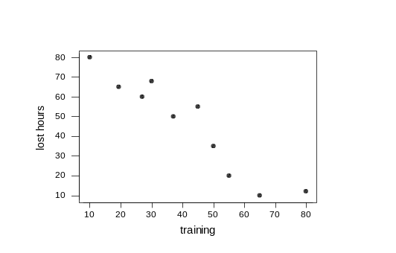
51. This relationship can best be described as…
a) Moderate and positive b) Weak and negative
c) Strong and negative d) Nonlinear but strong

52. What can you say about the relationship between safety training and productivity?
a) Training makes little difference in how many injuries people suffer.
b) People who have more training seem to have more injuries on the job.
c) In order to decrease training time, managers should focus on safety.
d) none of the above

53. If we give 100 hours of safety training to all divisions, lost hours due to accidents will be totally eliminated. This is an example of:
- misuse of cause and effect b) restricted range problem
c) extrapolation d) potential lurking variables

Questions 54-57 EasyCar Used Vehicles is analyzing the effectiveness of its advertising strategy to see if it can improve car sales. The dealer kept a record of how many television ads she placed each week, along with the number of cars sold in that same week. Below is the fitted line plot of the data:
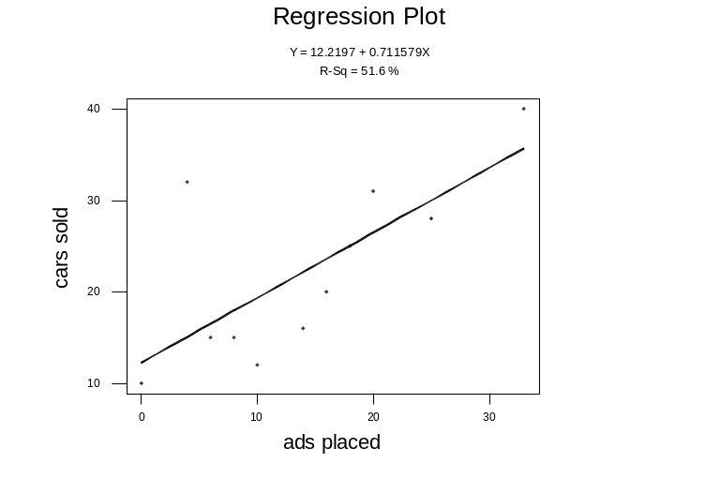
54. Which of the following are true statements that characterize the unusual observation(s) in this scatterplot?
I.The point at (33, 40) is an influential outlier.
II. The observation at (4,32) has a large residual.
III. The point at (4, 32) is an outlier.

- only I
- only III
- II and III
- I, II, and III

55. Consider the observation at (4, 32). Which sentence below could be true about that week?
a) Since so few cars were sold, we might guess that the ads were ineffective.
b) The dealer placed many ads that week, so it makes sense that she sold many cars.
c) Although few ads were placed that week, sales were highly successful.
d) The dealer may have placed the advertisements on the wrong channel that week.

56. Which statement describes the overall relationship between these two variables?
a) There is a moderate, positive correlation.
b) The relationship is strong and negative.
c) The relationship is weak but positive.
d) There is no linear relationship between these two variables.

57. The time of day and the channel of broadcast are examples of:
- Explanatory variables b) Lurking variables
c) Response variables d) Influential variables
Questions 58-62 A recent news article by the Associated Press reports that, “too little sleep – or too much – may raise the risk of developing heart disease, according to a study of nearly 72,000 nurses.” Compared to those who average eight hours of sleep a night, women who sleep five or less hours were 39 percent more likely to develop heart disease, while those who sleep nine or more hours had a 37 percent higher risk. “Researchers could not explain the findings, but suggested those women might have slept more because of underlying illnesses.”

Match each of the following with the corresponding elements of the study.

58. response variable: _____ a) nurses
59. explanatory variable: _____ b) average number of hours of sleep
60. lurking variable: _______ c) underlying illnesses
61. experimental units: _______ d) risk of heart disease

62. Based on the information above, we can say that the relationship between the explanatory and response variables for this data is:
- Weak
- linear
- curved
d) causal

Questions 63-66 Can aspirin help prevent heart attacks? The Physician’s Health Study involved a group of 22,000 male physicians in answering this question. Half of the doctors (11,000) took an aspirin tablet a day, while the rest took a placebo. After 4 years, those who received aspirin had significantly fewer heart attacks than those who took no aspirin.

63. What are the experimental units in this scenario?
- Heart attacks b) Aspirin and Placebo
c) Years d) Doctors

64. How many factors are there?
- one, with two levels b) two, with one level each
c) 22,000 with two levels d) 11,000 with one level each

65. What are the treatments?
- Heart attacks b) Aspirin and Placebo
c) Years d) Doctors

66. What is the response variable?
- Heart attacks b) Aspirin and Placebo
c) Years d) Doctors

Questions 67-70 Rogaine is a pharmaceutical product developed by Upjohn, which is advertised as "The only product ever proven to regrow hair." Advertisements in national magazines outline the results of clinical tests, in which 347 women with diffuse hair loss were randomly assigned to use either Rogaine or a placebo (a similar solution without the active ingredient.) To avoid biasing the results, patients were not aware of which product they were using. The product was applied by rubbing it into clean, dry scalp twice a day. After 8 months participants reported whether they had experienced moderate, minimal or no hair regrowth. The following table contains the data:

Regrowth | Moderate | Minimal | None | Total
Rogaine | 33 | 70 | 72 | 175
Placebo | 12 | 57 | 103 | 172
Total | 45 | 127 | 175 | 347

67. What are the experimental units?
- women
- women with hair loss
- men and women with hair loss
- men with hair loss
- Americans

68. If those 347 people were a random sample, we could extend the conclusions of this study to:
- all women with diffuse hair loss
- all adults with hair loss
- all people who participated in the study
- all people who use Rogaine

69. We include a placebo group in this experiment to account for the reported hair regrowth that can be attributed to:
a) the physiological effect of rubbing your head twice a day, which may stimulate the scalp.
b) the psychological effect of participating in a study and being more aware of small changes.
c) the desire of all participants to see some hair regrowth, whether real or imagined.
d) all of the above.

70. This is an example of:
- a blind, controlled experiment
b) a stratified, convenience sample
c) an biased, observational study
d) a multistage, randomized design

Questions 71-72 A researcher wishes to study how the average weight Y (in kilograms) of children changes during the first year of life. He plots these averages versus the age X (in months) and decides to fit a least squares regression line to the data with X as the explanatory variable and Y as the response variable. He computes the following quantities.

r= 0.9

71. The slope of the line is
- 0.30
- 0.88
- 1.01
- 3.0

72. What is the fraction of variation of weight of children during their first year that is explained by their age in months?
a) 0.33
b) 0.81
c) 0.90
d) 0.95

73. Which of the following is a true statement about probabilities?
a) A Probability can be negative.
b) Probabilities must be less than one half
c) A probability can not be greater than 1.
d) You can never have a probability of 0.

74. Why do we use inferential statistics?
- to help explain the outcomes of random phenomena
- to make informed predictions about parameters we don’t know
- to describe samples that are normal and large enough (n>30)
- to generate samples of random data for a more reliable analysis

75. Parameters and statistics…
- Are both used to make inferences about ‾x
- Describe the population and the sample, respectively.
- Describe different groups of individuals.
- Describe the same group of individuals.

Questions 76-77. The probability that any one of the incandescent lights in Norman Hall is not working is 0.10. There are 8 lights in Norman Hall. Assume that the lights are independent.

76. What is the probability that all of the lights are working?
a.) 0.4305
b.) 0.5965
c.) 0.00000001
d.) 0.9999

77. What is the probability that at least one of the lights is not working?
a.) 0.4305
b.) 0.5695
c.) 0.00000001
d.) 0.9999

Questions 78-79 Recent studies have shown that 20% of Americans are fit the medical definition of obese. A nutrition professor would like to study the percentage of students on campus that are obese. Suppose that the percentage of students that are obese at UF is the same as the percentage of Americans. Let X equal the number of students that are obese.

78. She takes a random sample of 10 teenagers. What is the distribution of X?
a.) X~Binomial(10, 0.2)
b.) X~Normal (10, 0.2)
c.) X~Normal (2, 1.27)
d.) X~ Normal (0.2, 0.126)

79. What is the probability that one of the people in her sample of 10 is obese?
a.) 0
b.) 0.10734
c.) 0.268435
d.) 0.375809

Question 80-82 Suppose 20 donors come to a blood drive. Assume that the blood donors are not related in any way, so that we can consider them independent. The probability that the donor is O- blood is 0.06, which is constant from donor to donor. Let X = the number of donors that have O- blood.

80. What is the distribution of X?
a.) X~Binomial(20, 0.06)
b.) X~Normal (1.2, 1.06)
c.) X~Normal (0.06, 0.0531)
d.) Can’t be determined

81. What is the probability that two donors have type O- blood?
a.) 0.225
b.) 0.290
c.) 0.370
d.) 0.885

82. What is the probability that 1 or more donors have type O- blood?
a.) 0.290
b.) 0.370
c.) 0.630
d.) 0.710

Questions 83-86 For a sales promotion the manufacturer places symbols under the caps of 10% of all Pepsi bottles. You buy 6 random bottles of Pepsi. Assume that the bottles are independent.

83. What is the probability that all of the bottles have the winning symbols?
a.) 0.10⁶ b.) 0.90⁶
c.) 1-.90⁶ d.) 1-.10⁶

84. What is the probability that none of the bottles have a winning symbol?
a.) 0.10⁶ b.) 0.90⁶
c.) 1-.90⁶ d.) 1-.10⁶

85. What is the probability that at least one of the bottles has a winning symbol?
a.) 0.10⁶ b.) 0.90⁶
c.) 1-.90⁶ d.) 1-.10⁶

86. What is the probability that at least one of the bottles does not have a winning symbol?
a.) 0.10⁶ b.) 0.90⁶
c.) 1-.90⁶ d.) 1-.10⁶

Questions 87 -90 It is though that the number of damaged cans in a boxcar shipment (Y) is a function of the speed of the boxcar (X) upon impact. The speed of the boxcar goes from 0 to 16 ft/s. The summary statistics of thirteen (13) boxcars appears below.
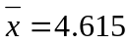, 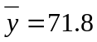, 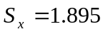, 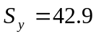, 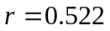

87. For now let’s say the slope is an arbitrary positive number k. How do we interpret the slope for this regression equation?

- The slope is the number we get from plugging the numbers into the equation.
- For every one unit increase in the speed of the boxcars, the number of damaged cans decreases by k.
- For every one unit increase in the speed of the boxcars, the number of damaged cans increases by k.
- There is not enough information to answer this question.

88. Compute the actual slope.
- 42.9
- 22.6
- 11.8
- 15.6
- -11.8

89. The y-intercept for this equation is 17.343, can this be interpreted given the context of the problem?

- Yes, it turns out that when we have a speed of 0 from the boxcar, we have about 17 damaged cans.
- Yes, it turns out that when we have a speed of 0 from the boxcar, we have about 72 damaged cans.
- No, there is no such thing as a speed of 0, we cannot interpret the y-intercept.
- There is not enough information to answer this question.

90. A different set of data was used and they have a different regression equation of 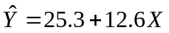, compute the predicted number of damaged cans in the boxcar for a speed of 15.
- 15
- 12.6
- 25.3
- 214.3

Questions 91 – 93 A popular fashion magazine has just recently published a poll saying that 45% of women who, if given the chance, would want to marry their first boyfriend. A random sample of 20 women from across the United States was taken. Answer the following questions.

91. This is clearly a binomial experiment. Which of the following is not a property of the Binomial?

- The observation for each woman is independent, since the women were randomly sampled.
- Each woman has the same probability they would like to marry their first boyfriend (45%).
- Each woman in the survey has based their response upon another woman’s response.
- There is not enough information to answer this question.

92. What is the probability that half of the women sampled would like to marry their first boyfriend?
- 0.4500
- 0.1593
- 0.5513
- 0.6312
- Not enough information to answer this question.

93. Let’s say we increased our sample to 100 women, what is the expected number of women in this new sample that would say that they would like to marry their first boyfriend?
- 45
- 55
- 65
- 75
- 35

Questions 94-95 When parking a car in a downtown parking lot, drivers pay according to the number of hours. The probability distribution for the number of hours a car is parked has been given below:

x | 1 | 2 | 3 | 4 | 5 | 6 | 7 | 8
P(x) | 0.24 | 0.18 | 0.13 | 0.10 | 0.07 | 0.04 | 0.04 | 0.20

94.What is the probability that a car will be parked in this parking lot for at least 6 hours?
- 0.04
- 0.28
- 0.24
- 0.10
- 0.18

95.What is the expected number of hours a given car will be parked in the parking lot?
- 3.86
- 2.84
- 5.63
- 10.23
- 4.52

96.The data set below gives the length of a bear in inches and the weight of the bear in pounds. Without calculating the value of r, what is the linear correlation coefficient between length and weight?
Length Weight
- 65
  - 70
- 74
- r=.92 pounds
- r=.92 inches
- r= 9.2
- None of the above

97.If we divide the length of the bears by 12 so that the length is now in feet, will the linear correlation coefficient between length and weight change?
- yes, it will change
- no, it will not change
- not enough information
- maybe it will change

98.Which of these statements is false?
- A parameter, in practice, is an unknown number describing the population.
- A statistic is used to estimate an unknown parameter.
- A parameter is used to estimate an unknown statistic.
- Statistics can change from sample to sample.

99.For X~N(1, 12), find the probability P(X=5).
- 0
- .1
- .01
- .98

100.The length of human pregnancies is approximately normal with mean 266 days and standard deviation 16 days. How short are the shortest 2.5% of all pregnancies?
a) less than 234.64
b) less than 203.28
c) less than 244.4
d) less than 255.2

101. A player flips two fair coins and counts the number of heads. We must find the probability distribution for X={number of heads}. What should the value of “Q” be to complete the probability distribution?
X P(x)
0 .25
1 Q
2 .25

a) .5 b) .25 c) .05 d) 1

102.Which of the following is/are true about a skewed right distribution with extreme outliers?
  - The mean is greater than the median
  - The median should be used as the measure of center because it is more resistant to extreme observations than the mean
  - The standard deviation should be used as the measure of spread because it is more resistant to extreme observations than the range or inter-quartile range

- I and II only
- I and III only
- II only
- I, II, and III

103.Suppose a survey of US adults reports a correlation of r=0.92 between the amount of junk food a person consumes and their weight. Which of the following can we say about the results?

- That the junk food causes weight gain
- That the results are from an experiment
- That there is a strong positive linear relationship between the amount of junk food a person consumes and their weight

- III only
- I and III only
- I and II only
- I, II, and III

104.A study investigated the relationship between the number of hours of sleep that a person got the night before and their response time(in seconds) on a manual dexterity test. The correlation coefficient was equal to 0.7183 and the least squares regression equation was response time=12.22+0.71hours. What of the statements below is a true statement?

- That 71.1579% of the variability in the number of hours slept is explained by response time
- That 71.1579% of the variability in response time is explained by the number of hours slept
- That 51.6% of the variability in the number of hours slept is explained by response time
- That 51.6% of the variability in response time is explained by the number of hours slept

105.Which of the following is/are true about a normal distribution?

        - If the same area is shaded in the lower tail and in the upper tail, the probabilities of the lower and upper tail are equal.
        - The mean is equal to the median
        - It is a continuous distribution
        - All of the above are true

106.Suppose that you had a distribution of rolling a fair 6 sided dice. What can we say about the distribution?

- It is uniform.
- Each of the observations are equally likely.
- It has a mean equal to 3.5.
- All of the above.

107.Ron thinks he's kind of a big deal and decides to challenge Veronica to an
Anchorperson Aptitude Test (AAT). The average anchorperson scores 100 points (out of
200 possible points), with a standard deviation of 4.5 points. Brick, the newsroom's shuttle diplomat, gets both parties to agree that being a "big deal" would require an anchorperson's score to beat 97.5% of the other scores. Ron scores 111 and Veronica scores 117. Assuming AAT scores are normally distributed, which statement is true?
a) Only Ron is a Big Deal.
b) Both Veronica and Ron are a Big Deal.
c) Only Veronica is a Big Deal.
d) Neither Veronica nor Ron are a Big Deal.

108.In a colony of woodchucks, a given woodchuck can chuck an average of 4.82 chords
of wood per hour. Sparky the woodchuck statistician asserts that the number of chords
of wood each woodchuck can chuck per hour is normally distributed, with a standard
deviation of .3 cords of wood per hour. In his old age, Grandaddy Woodchuck has lost
most of his woodchucking capability and is nearing retirement - he can only chuck
4.4 chords per hour. What is the probability that a woodchuck can chuck more wood
per hour than Grandaddy Woodchuck(4.4 chords per hour) but can’t chuck any more than 5.12 chords of wood per hour?
a) .7605
b) .8643
c) .9192
d) none of the above

109.In studying the incidence of surf wax toe-burn among Florida's east coast skin boarders, over several years Shelley the Shands medical student has interviewed a sample of 100 people that skin boards on the east coast of Florida. Shelley wants to publish her astonishing results - that the mean pain level (on a scale of 1 to 10) of toe-burn among Florida's skin boarders is 7.5. In the discussion portion of Shelley's research paper,
include the word ______________ to describe the mean value she discovered.
Fill in the blank.
a) "statistic"
b) "parameter"
c) Neither (a) nor (b) have anything to do with Shelley's medical research.
d) Shelley can use either (a) and (b) because these words are interchanged freely.

110.Phlebotomists(those who draw blood for analysis) at the NW 12 Street blood plasma donation center have found that 15% of their donors eat more than three cookies following their plasma donation. On a given day, 13 donors give plasma. What is the probability that less than two of the day's donors will eat more than three cookies after they donate blood plasma?
a) .398
b) .692
c) .121
d) .277

111.The University of Florida’s zip code is 32612, is this a categorical or quantitative variable?
- Categorical
- Quantitative
- Neither

112. Gubernatorial candidates Charlie Crist and Jim Davis each roll a die. Let the random variable X be the sum of the numbers on the two dice. Below is the probability distribution for all possible sums of the rolls of the dice. What is the missing probability?
X=2 | X=3 | X=4 | X=5 | X=6 | X=7 | X=8 | X=9 | X=10 | X=11 | X=12
1/36 | 1/18 | 1/12 | 1/9 |  | 1/6 | 5/36 | 1/9 | 1/12 | 1/18 | 1/36
- 1/36
- 4/36
- 5/36
- 7/36

113.A bored student during class flips a fair coin 5 times. Assuming the flips are independent. What is the probability he gets exactly 3 heads and 2 tails?
- ½
- ¾
- 5/16
- 5/64

114. In a large class, the instructor ran a regression with the independent variable(x) as the grade on the first exam and the dependent variable(y) being the grade on the second exam. She found the equation to be: Y = 29.25 + .57X
Knowing that your friend got a 78 on the first exam, what value would you predict she got on the second exam?
- 73.71
- 72.57
- 78.00
- 71.43

115. Suppose during practice Shaq shoots 50 free-throws and he makes a free-throw 70% of the time. (Assume that each free-throw is independent of any other free-throw.) Let X be the number of free-throws Shaq makes during practice. What is the distribution of X?
- X ~ Normal (0.7,50)
- X ~ Binomial(50,0.7)
- X ~ Binomial(0.7,50)
- Can’t be determined from the given information

116.Suppose that a new scoring system for universities was created which has a scale of 0-100. The scores on scoring system are normally distributed with a variance of 100. If the average score for universities is a 65, what score would the University of Florida need to have in order to be in the top 10% of universities?
- 95.1 or more
- 62.1 or more
- 75.1 or more
- 77.8 or more

SOLUTIONS

- B. The tail points to the lower numbers

- C. About half the scores are lower than 155 and half are higher. So, the midpoint of the distribution is close to 155.

- A. Most of those scores are higher than 120, except 94.

- B. We should add together all the students who took longer than 90 min to finish the test. About 6 took between 90 ~105 and about 4 took between 105~120. The total should be around 10.

- B. The balancing point of the distribution is between 45~60. The center should be between 45~60 min.

- A. The data is slightly skewed right. So the mean will be higher than the median.

- C. Pos.= (n+1)/2=20/2=10. 75 is at position 10. The median is 75.

- C. IQR= Q3-Q1= 83-62=21.

- A. Use your calculator.

- B Since it follows the standard normal distribution, the standard deviation(s) equals to one. S= variance = 1.
- A. Z= (42-50)/10=-0.8. Enter table A under Z=-0.8. The table entry is 0.2119. This is the area to the left of –0.8. Because the total area under the curve is 1, the area lying to the right of –0.8 is 1-0.2119=0.7881.

- A. Standardize first, and we can get –1.7 < x < -0.2. Then, look at the table, the total area should be .4207 – .0446= .3761

- D. We want to find the score x with area 0.03 to its right under the normal curve. That’s the same as finding the score x with area 0.97 to its left. Use the table A for the entry close to 0.97. It is 1.88. Then, unstandardize it, x = 50 + 1.88*10=68.8.

- C. The entry corresponding to z= -1.34 is 0.0901 (this is the probability less), so, this shows most of students’ scores (90%) are higher than you.

- C Z= (48-60)/12=-1

- B. Look the table A, the entry corresponding to the z-score is 0.1587.

- A. Unstandardize the z-score. X= 60+12*5.2=122.4. 122.4 is much larger than the mean( =60).

- B. Range= max- min. And here, the first quartile is bigger than the min, so the IQR = Q3-Q1 is smaller than the range.

- A. For example, N~(2, 20) is also a normal distribution. The mean can be positive, negative or zero.

- D. Because the variance involves squaring the deviations, it does not have the same unit of measurement as the original observations. However, the standard deviation s measures spread about the mean in the original scale.

- A. Z = (9200-7500)/ 1500=1.13. Enter table A under Z=1.13. The table entry is 0.8708. This is the area to the left of 1.13. Because the total area under the curve is 1, the area lying to the right of 1.13 is 1-0.8708=0.1292

- C. Standardize first, and we can get –1.4 < x < .47. Then, look at the table, the total area should be .6808 – .0808= .6

- D. Standardize first, and we can get –2 < x < 1. Then, look at the table, the total area should be around 81.5%.

- B. Since the median is smaller than the mean, we can conclude it’s a skewed right graph.
- B. Since it is a skewed distribution, the median is better than mean.

- B. For the skewed right graphs, the mean is farther out in the long tail than is the median. So, the mean is greater than the median.

- A. Approximately 95% of the observations fall within 2of .
62-2*12=38. 62+2*12=86. So the range is 38~86.

- A. Standardize first, and we can get –1 < x < 1. Then, look at the table, the total area should be .8413– .1587 = .6826. Or use 68. 95. 99.97 rule, 50 and 74 are 1 standard deviation from . So 68.5% of the data is between the points.

- B. We want to find the score x with area 0.05 to its right under the normal curve. That’s the same as finding the score x with area 0.95 to its left. Use the table A for the entry close to 0.95. It is 1.645. Then, unstandardize it, x = 62 + 1.645*12=81.74.

- B. Z= (45-62)/12=-1.42. Enter table A under Z=-1.42. The table entry is 0.0778.
.0778*100%=7.78%

- B. The definition of “slope”. (For every one unit increases in x, y increased by b units).
- A. r= 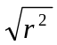=0.6862944. The slope is positive, so r is also positive.

- D. The use of a regression line for prediction far outside the range of values of the explanatory variable that you used to obtain the line.

- C. Our predicted sales is –762+18.53*90=905.7.
So the residual should be res = obs y- predy= 1100-905.7=194.3.

- B. When you substitute into the equation of the regression line, the result of is always equal to the mean of y. ( p 142)

- B. The use of chance to divide experimental units into groups is called randomization.

- C. Voluntary response sample consists of people who choose themselves by responding to general appeal.

- D. An observation study observes individuals and measures variables of interest but does not attempt to influence the response.

- A. When we confound two variables means that we cannot distinguish their effects on the response variable.

- A. In a matched pairs experiment we have experimental blocks consisting
of two subjects, each one receiving one of the two treatments, or we have
each subject receiving both treatments.

- A. There is not an apparent trend to the data. We cannot find any relationship between those two variables.

- C. Since we know the correlation is 0.755, there’s a fairly strong positive linear relationship between those two variables.

- C. We can use those formulas: slope = b = r *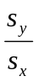 and intercept = - b*. = a
b = r*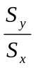=.755* (11.35/13.66)=.627.
a = - b*=78.4- .627*(74.7)=31.5.

- B. The point doesn’t cause the regression line’s slope to change, so it is not influential.
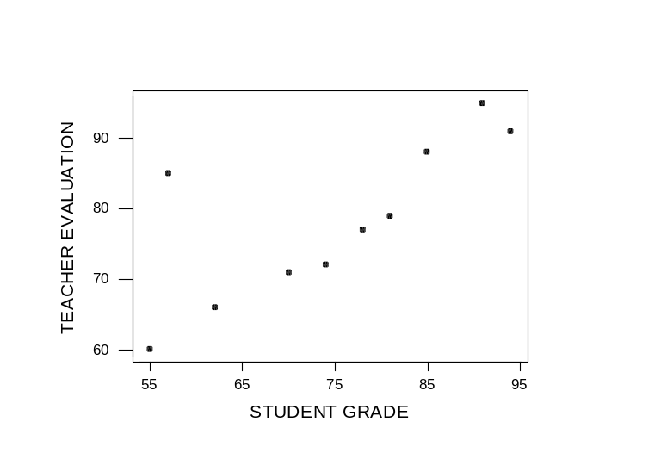
- B. The definition of “slope”. (For every one unit increases in x, y increased by b units).

- A. X = 0 makes sense here, so the average GPA of someone who doesn’t drink is 3.45.

- A. The definition of R, is the percentage of the variation of y that is explained by x.
- C. Since the slope is negative, the r= -= -.564.

- C. (22+6)/(100+100)

- A. An experiment deliberately imposes some treatment on individuals in order to observe their responses.

- C. It shows clearly a strong negative linear relationship between two variables.

- D. More training is associated with less injuries.

- C. The use of a regression line for prediction far outside the range of values of the explanatory variable that you used to obtain the line.

- C. The point at (4 , 32) is an outlier and it has a large residual.

- C.

- A. We can see a positive linear trend in the scatter plot. The data set is positive because x increases so does y.

- B. A lurking variable is a variable that is not among the explanatory or response variables in a study and yet may influence the interpretation of relationships among those variables.

- D. Measures an outcome of a study.

- B. Explains or causes changes in the response variable.

- C. A lurking variable is a variable that is not among the explanatory or response variables in a study and yet may influence the interpretation of relationships among those variables.

- A. The individuals on which the experiment is done are the experimental units.

- C. Since the risk of developing heart disease is getting higher either when sleeping too little or too much, the scatter plot should have a curve trend between those two variables.

- D. The individuals on which the experiment is done are the experimental units.

- A. The explanatory variables in an experiment are called factors.

- B. A specific experimental condition applied to the units is called a treatment. If there is one factor, the number of treatments equals to the number of levels.

- A. A response variable measures an outcome of a study.

- B. The individuals on which the experiment is done are the experimental units.

- A. Since we select the random sample to represent the whole population of women.

- D.

- A. Because the experiment enables us to control the effects of outside variables on the outcome. A blind experiment is an experiment where participant does not know what treatment he is getting.

- A. Slope = r *. b = (0.9)*(1.2/3.6)= 0.30. So we can calculate the slope equals to .30

- B. Find the R= .9*.9=.81. Definition of R: the percentage of the variation of y that is explained by x.

- C. The probability P(A) of any event A satisfies 0P(A)1.

- B. Because we infer conclusions about the population from data on selected
Individuals (all sample).

- B. A parameter is a number that describes the population. A statistic is a number that describes the sample.
- A. P (8 lights are working)=(.9)=.4305 because of independence.
- B. P (at least one of the lights is not working)
=1- P(all lights are working) =1-.4305=.5695

- A We have an X which is the number of successes. The situation follows the requirements for a Binomial Experiment. X~ Binomial(n, p) → X~ Binomial ( 10, 0.2)

- C Since X is binomial we can use the binomial probability function to find the probability that X = 1.
- A We have an X which is the number of successes. The situation follows the requirements for a Binomial Experiment. X~ Binomial(n, p) → X~ Binomial ( 20, 0.6).

- A Since X is binomial we can use the binomial probability function to find the probability that X = 2.
- D Since X is binomial we can use the binomial probability function to find the probability that X ≥ 1. 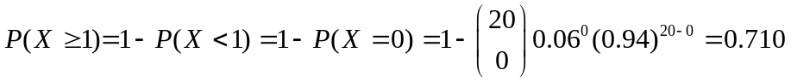.
- A, A Probability that one cap has a winning symbol is 0.10. Since the caps are independent, you can multiple the probabilities of getting a winning symbol on the first cap and on the second cap and on the third cap, fourth, fifth and sixth to get the probability that they all have winning caps. P(all have winning symbols) = P(1st cap wins)*P(2nd cap wins) *P(3rd cap wins) * P(4th cap wins)* P(5th cap wins)*P(6th cap wins) = 0.10*0.10*0.10*0.10*0.10*0.1=0.10⁶

- B The probability that cap does not have a winning symbol is 0.90. The caps are once again independent so you can multiply the probabilities that the caps do not have winning symbols.
P(all have winning symbols) = P(1st cap doesn’t win)*P(2nd cap doesn’t win) *P(3rd cap doesn’t win) * P(4th cap doesn’t win)* P(5th cap doesn’t win)*P(6th cap doesn’t win) = 0.90*0.90*0.90*0.90*0.90*0.9=0.90⁶

85. C The P(at least one bottle wins) = 1- P(none of the bottles win) = 1- 0.9⁶

86. D P(at least one of the bottles doesn’t win) = 1- P(all of the bottles win) = 1-0.1⁶

- C, in general a slope k implies that a one unit increase in the X variable will give a k unit increase in the Y variable. In this case, for every one unit (ft/s) increase of the boxcar, the number of damaged cans increases by k.

- C, (42.9/1.895)*(0.522 ) = 11.8
- A, since we can technically have a speed of 0 from the boxcar, it follows that plugging in 0 in an equation with an intercept of 17.343 would imply that at a velocity of 0, we will have about 17 damaged cans.
- D,Y(15) = 25.3 + 12.6*(15) = 214.3
- C, in a binomial experiment, we know that each trial is independent of the other ones, so it would not make sense for one woman’s response to depend on another woman’s response.
- B,P(X=10) = 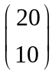*(.45)¹⁰(.55)¹⁰ = 0.1593
- A, E(X) = np = (100)(.45) = 45
- B, P(X>= 6) = 0.04 + 0.04+ 0.2 = 0.28
- A
E(X) =
= (1)(.24) + (2)(.18)+(3)(0.13)+(4)(0.10)+(5)(0.07)+(6)(0.04)+(7)(0.04)+ (8)(.20) = 3.86
- D; Correlation has no units and is bound between negative one and one.

- B; Since correlation has no units, its value will remain the same whether length is measured in feet or inches. Remember that correlation measures the direction and the strength of the relationship. Dividing both variables by 12 will not change the direction or the strength.

- C; Parameters describe the population and are unknown. Statistics are estimates for these parameters calculated from the sample.

- A; Since the normal distribution is continuous over the real number line, that means that there is an infinite amount of numbers on the line. You can think of infinite as a really really big number, like 9999999. So, the probability at one point can be thought of as 1/infinity = almost zero. (type 1/9999999 into your calculator and you will see this is approximately zero).

- A;
P(X<x)=.025
Z= (x-266)/16=.025
Looking up .025 in the Z-Table yields approximately -1.96. Thus,
x= z * sigma + mu = -1.96*16 + 266 = 234.64

101. A; In a probability distribution, the total probabilities must sum to one. Thus,
1= P(0) + P(1) +P(2)
1 =.25 + Q + .25
1=.5 + Q
Q= 1-.5
Q=.5

- A; roman numeral one is true because an extremely large value out in the right-hand tail pulls the mean to the right; roman numeral two is true because the calculation of the mean uses all the numerical values, so unlike the median, it depends on how far observations fall from the middle, therefore the median is said to be resistant to extreme observations; roman numeral three is false because the standard deviation, which uses the mean, is very sensitive to extreme observations.
- A; roman numeral one is false because correlation does not imply causation, it could be that the junk food causes weight gain, that the weight gain causes increased junk food, or some variable C causes weight gain; roman numeral two is false because the question states that it was a survey and that no treatments was applied; roman numeral three is true because it gives the correct strength and direction of the correlation.

- D; Variance=r²=(.7183)²=.516, convert to percent by multiplying by 100=51.6%Interpretation of R-squared: It is the variability of y (response time) that is explained by x (number of hours slept).

- D; A normal distribution is by definition symmetric which means if there is the same shaded areas of the upper and lower tails, their probabilities are equal; the mean is equal to the median because the distribution is symmetric; a normal distribution is by definition continuous.

- D; when rolling a fair dice there is an equal probability (1/6) of getting a 1, a 2, a 3, a 4, a 5, or a 6, thus the distribution is uniform; This particular type is a discrete uniform distribution. each of the observations are equally likely because the problem states that it is a fair dice;

x | 1 | 2 | 3 | 4 | 5 | 6
P(x) | 1/6 | 1/6 | 1/6 | 1/6 | 1/6 | 1/6

the mean is (1/6)1 + (1/6)2+ (1/6)3+(1/6)4+(1/6)5+(1/6)6 = (1/6) (1+2+3+4+5+6) =(1/6) 21= 3.5.

- B, To be a big deal, you must score higher than 97.5% of the others. The score at the 97.5th percentile (z=1.96), is x= 1.96*4.5+100 = 108.82. Since both Veronica and Ron scored higher than 108.82, both are a big deal.

- A, since z(grandaddy) = (4.4-4.82)/.3 = -.42/.3 = -1.4
and z(5.12) = (5.12-4.82)/.3 = 1,
so P(less than -1.4) =0.0808 and P(less than 1) = 0.8413
Probability in between 4.4 and 5.12 is 0.8413 – 0.808 = 0.7605

109. A since Shelley has only dealt with a SAMPLE of the skin boarders.

110. A
P(X<2) = P(X<=1) = P(X = 0) + P(X = 1)
= [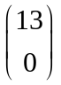*(.15)⁰*(.85)¹³] + [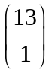*(.15)¹*(.85)¹²]
=.121 + .277 = .398

111. A; It is a categorical variable; zip code is a category that just happens to be numeric. If you averaged 5 zip codes, the average has no meaning.

112. C; To find the missing probability we realize that the total probabilities sum to 1, so 1 – 1/36 – 1/18 -1/12 -1/9 -1/6 -5/36-1/9-1/12-1/18-1/36 = 5/36

113. C; This is binomial, because we have independent and identical n trials, and constant proportion p. In this case, p = 0.5 because it is a fair coin and n =10. 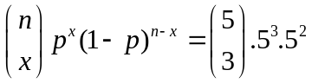 = 5/16

114. A; Y = 29.25 + .57X
Y=29.25+.57*78 = 73.71

115. B; Because each trial is independent and we have 50 trials and we know our proportion is .70 and each outcome is either a success or failure, we know that X is Binomial with p=.70 and n=50

116. Looking up .9049 in the table yields Z=1.28
x= z * sigma + mu = 1.28*10 + 65 = 77.8

OR

1.28 = (x – 65) / 10
12.8 = x -65
X = 77.8

